Traditional Chinese Games (Activity Village)

Catch The Dragon's Tail
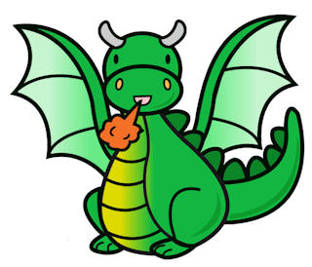
This traditional Chinese game is great fun for the playground. You will need a large group of children - at least 10, but the more the merrier!
Age: Any
The children all form a line with their hands on the shoulders of the child in front. The first in line is the dragon's head, the last in line is the dragon's tail.
The dragon's head then tries to catch the tail by manoeuvring the line around so that he can tag the last player. All the players in the middle do their best to hinder the dragon's head. Don't let the line break!
When the head catches the tail, the tail player takes the front position and becomes the new dragon's head. All the other players move back one position.

Cat Catching Mice
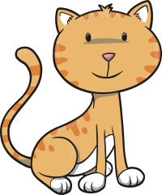
This traditional Chinese chase game can cause much screeching and excitement! Play outdoors - or indoors, if you have a large room. It is also known simply as "Cat and Mouse".
Age: Any
One child is chosen to be the Cat (the chaser) and one child is chosen to become the Mouse. All the other children form a circle, holding hands, with the Mouse inside and the Cat outside.
The children in the circle move around while calling out the following rhyme:
"What time is it?" "Just struck nine." “Is the cat at home?" "He's about to dine."
When the rhyme stops, the children stop moving and the Cat starts to chase the Mouse, weaving in and out of the ring of children to do so. However, the Cat MUST follow the mouse's path. When he catches the Mouse he can enjoy pretending to "eat" him, and then two more children take a turn.

Chinese Ball
This traditional Chinese playground game develops children's ball skills and their concentration - it really keeps them on their toes!
Age: 6+
Children stand around in a circle with a ball as appropriate for the age group (such as a basketball).
The ball is thrown quickly around and across the circle. When a child catches the ball, the children on either side must raise one arm - the arm nearest the child with the ball - and hold it in the air until the ball is passed on to another child.
If a child fails to catch the ball, or fails to raise the correct arm when their neighbor catches the ball, or is too slow to pass the ball along, they drop out. When there are only 5 children left in the circle, they are all declared winners, and the game starts again

