Merry Grinchmas!
December to Remember Schedule:
Wednesday, December 27th
Sertoma Unit Boys & Girls Club

 | Games Room | Learning Center | Pre-Teen Center | Gym | Art Room
7:30am | Table Top Games & Coloring  8:30am-Breakfast | LEGOS & A Movie  8:30am-Breakfast | CLOSED | CLOSED | CLOSED
8:55am | SWITCH TIME | SWITCH TIME | SWITCH TIME | SWITCH TIME | SWITCH TIME
9:00am | Grinch Stations:  Pin the Heart on the Grinch, Carpetball the Grinch, Just Dance | The Grinch Bingo & Christmas Music | The Grinch Fruit Building & A Christmas Cartoon | Bat the Grinch | Grinch Drawing Experiment & Movie
9:55am | SWITCH TIME | SWITCH TIME | SWITCH TIME | SWITCH TIME | SWITCH TIME
10:00am | Grinch Stations:  Pin the Heart on the Grinch, Carpetball the Grinch, Just Dance 11:00am-Lunch | The Original Grinch Movie & Snacks  11:00am-Lunch | Terribly Terrific  Tablets and Chromebook Craze  11:00am-Lunch | The Grinch Dodgeball  11:00am-Lunch | Grinch Drawing Experiment & Movie 11:00am-Lunch
11:30am | SWITCH TIME (cafe) | SWITCH TIME (cafe) | SWITCH TIME (cafe) | SWITCH TIME (cafe) | SWITCH TIME (cafe)
12:30pm | Build the Grinch’s Lair & Video Games | Grow the Grinch’s Heart Science Experiment | Whoville Hair Boutique | Grinch Stations  Knockout the Grinch, WHOlahoop, Tagteam Throw | Grinch Slime
1:25pm | SWITCH TIME | SWITCH TIME | SWITCH TIME | SWITCH TIME | SWITCH TIME
1:30pm | Build the Grinch’s Lair & Video Games | Grow the Grinch’s Heart Science Experiment | Terribly Terrific  Tablets and Chromebook Craze | The Grinch Dodgeball | Grinch Slime
2:25pm | SWITCH TIME | SWITCH TIME | SWITCH TIME | SWITCH TIME | SWITCH TIME
2:30pm | MEMBER CHOICE  Snack-2:40pm | MEMBER CHOICE  Snack-2:40pm | MEMBER CHOICE  Snack-3:00pm | MEMBER CHOICE  Snack-3:20pm | MEMBER CHOICE  Snack-3:00pm
3:55pm | SWITCH TIME | SWITCH TIME | SWITCH TIME | SWITCH TIME | SWITCH TIME
4:00pm | The Grinch’s Table Top Tournament  Ping Pong, Pool, Air Hockey, Fooseball | The Grinch Reading Corner | The Grinch Fruit Building & A Christmas Cartoon | Grinch Stations  Knockout the Grinch, WHOlahoop, Tagteam Throw | Grinch Coloring Sheets
5:00pm | Consolidation in Games Room | Consolidation in Games Room | Consolidation in Games Room | Consolidation in Games Room | Consolidation in Games Room
Merry Grinchmas! Activity Instructions

 | Games Room | Learning Center | Pre-Teen Center | Gym | Art Room
Activity Instructions | Table Top Games & Coloring  Members will have free play.  Grinch Stations  Divide members into 3 groups. Members will play pin the heart on the Grinch, play carptetball, and use the XBOX to play Just Dance. Members will rotate in 15 minute rotations.  Build the Grinch’s Lair & Video Games  You can divide members into two groups. Members will use as many cupstacks as they can to build a tall tower or lair. Members will also rotate playing their chosen video games.  The Grinch’s Table Top Tournament  Divide members into four groups. Members will participate in a games room tournament! Use the tracking form to declare winners. Winners will receive prizes. Ping pong, pool, air hockey, and fooseball. | LEGOS & A Movie  Members will sit in groups and accomplish LEGO tasks and have free build time. Choose a member to pick a movie for the hour to play in the background.  The Grinch Bingo & Christmas Music  Members will play Grinch Bingo and listen to Christmas music.  The Grinch Movie & Snacks  Members will watch the original Grinch movie and enjoy Grinch themed snacks.  Grow the Grinch’s Heart  Take a green balloon and use your red Sharpie to draw a simple heart on the balloon. Give it a minute to dry before you begin your project. Next, add some vinegar to your empty water bottle. I filled it up to about the second groove from the bottom. Eyeball it. You don’t need to be exact. Attach your balloon to the bottom of your funnel. Fill the balloon with about two to three spoonfuls of baking soda. Remove it from the funnel. Carefully, without dumping any baking soda into your bottle, attach the balloon to the top of the water bottle. Lift the balloon up and shake the baking soda into the bottle. Your balloon will start inflating immediately. You can let go once the balloon starts filling up.  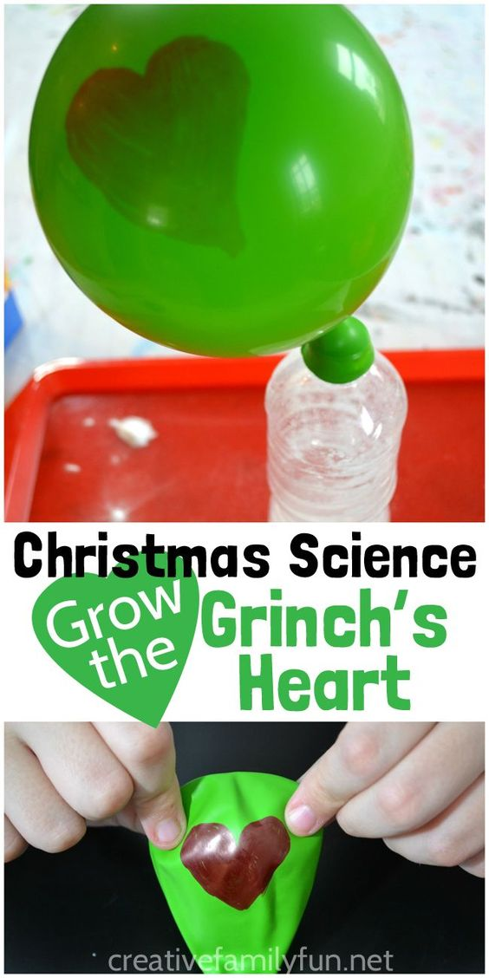  The Grinch Reading Corner  Members will listen to staff as they read Dr. Seuss’ How the Grinch Stole Christmas. | The Grinch Fruit Building & A Christmas Cartoon  Members will build their own Grinch healthy treats.  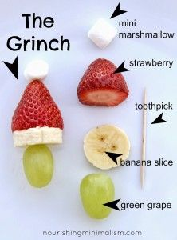  Terribly Terrific  Tablets and Chromebook Craze  Members will be able to visit the following websites and play games. Please write them on the board.  PBSkids.org  Coolmath.org  Code.org  Myfuture.net  Whoville Hair Boutique  Members will use empty water bottles, hair ties, ribbon, and hairspray to create whoville looks like the one below. | Bat the Grinch  Members will use the baseball net and automatic pitcher and try to hit the red heart on the net.  The Grinch Dodgeball  Members will play using the rules of traditional dodgeball and anyone who is out with a RED Heart Ball only has to sit for 10 seconds and can return to the game.  Grinch Stations  Divide members into groups of three.  Knockout the Grinch: Members will play knockout.  WHOlahoop:  Members will see how long they can hula hoop without dropping.  Member Tagteam Throw: Members will line up at opposite sides and continue throwing a ball back and forth, once someone drops the ball, that group is out. | Grinch Drawing Experiment & Movie  Members will follow along as the staff models how to make the Grinch. Once the base is complete, members can color their creations while watching a movie. Allow a member to choose the movie.  Grinch Slime  1 cup of green glitter glue  1 & 1/2 cups very warm water  a few drops of essential oil  Combine and mix the above ingredients in a bowl  In a second bowl combine  3/4 teaspoons of borax  1 & 1/3 cups very warm water  Mix the borax into the water and dissolve. Once the ingredients of both bowls are mixed combine both bowls. Mix the ingredients with your hands  here will be water left over in the bowl. That can be thrown away.  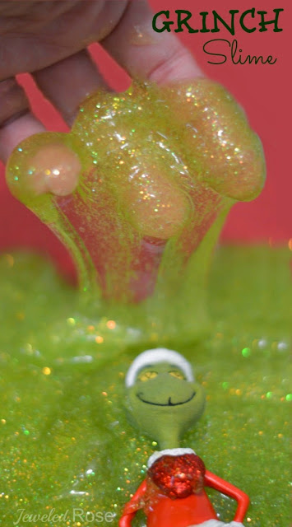  Grinch Coloring Sheets  Members will color Grinch themed coloring sheets and you can play Christmas music or show a Christmas movie in the background.
Merry Grinchmas! Supplies List

 | Games Room | Learning Center | Pre-Teen Center | Gym | Art Room
Supplies | Grinch Coloring Sheets, markers, crayons, pin the heart game, blindfolds carpetball materials, Just Dance game, cupstacks, video games, table top materials, tournament tracking form | LEGOS, Lego Cards, Christmas Movie, The Grinch movie (original), Grinch snacks, Grinch bingo sheets, red and green M & Ms, empty water bottles, green balloons, red sharpies, vinegar, baking soda, funnels, the Grinch book, ipod and speaker or chromebook Pandora | Christmas cartoon, banana, strawberries, toothpicks, mini marshmallows, green grapes, tablets, chromebooks, empty water bottles, hair ties, non-aerosol hair spray, ribbon, | Baseball net, red heart, tape, automatic pitcher, balls, bats, dodgeballs, 2 basketballs, hula hoops, balls | Cardstock, markers, movie, Grinch template, clear or green glitter glue, bucket or bowl, warm water, Christmas essential oil, borax, Grinch coloring sheets or coloring books, crayons

Additional supplies: green tic tacs for prizes, Grinch themed prizes

Winter Wonderland!
December to Remember Schedule:
Thursday, December 28th
Sertoma Unit Boys & Girls Club

 | Games Room | Learning Center | Pre-teen Center | Gym | Art Room
7:30am | Table Top Games & Coloring  8:30am-Breakfast | LEGOS & A Movie  8:30am-Breakfast | CLOSED | CLOSED | CLOSED
8:55am | SWITCH TIME | SWITCH TIME | SWITCH TIME | SWITCH TIME | SWITCH TIME
9:00am | Video Gamers & Snowman Building | DIY Snow & A Movie | Snowman Stress Balls | Snowball Fight Dodgeball | Snowflake Pipe Cleaners
9:55am | SWITCH TIME | SWITCH TIME | SWITCH TIME | SWITCH TIME | SWITCH TIME
10:00am | Video Gamers & Snowman Building 11:00am-Lunch | DIY Snow & A Movie  11:00am-Lunch | Snowman Stress Balls 11:00am-Lunch | Snowball Fight Dodgeball  11:00am-Lunch | Snowflake Pipe Cleaners  11:00am-Lunch
11:30am | SWITCH TIME in cafe | SWITCH TIME in cafe | SWITCH TIME in cafe | SWITCH TIME in cafe | SWITCH TIME in cafe
12:30pm | Table Top Tournament | Snowman Marshmallows & Christmas Music | Computer Craze | Snowball Toss Challenge/Outside | Penguin Projects
1:25pm | SWITCH TIME | SWITCH TIME | SWITCH TIME | SWITCH TIME | SWITCH TIME
1:30pm | Table Top Tournament | Snowman Marshmallows & Christmas Music | Computer Craze | Snowball Toss Challenge/Outside | Penguin Projects
2:25pm | SWITCH TIME | SWITCH TIME | SWITCH TIME | SWITCH TIME | SWITCH TIME
2:30pm | MEMBER CHOICE  Snack-2:40pm | MEMBER CHOICE  Snack-2:40pm | MEMBER CHOICE  Snack-3:00pm | MEMBER CHOICE  Snack-3:20pm | MEMBER CHOICE  Snack-3:00pm
3:55pm | SWITCH TIME | SWITCH TIME | SWITCH TIME | SWITCH TIME | SWITCH TIME
4:00pm | Board Games | Winter Wonderland Reading Corner | Snow White and Coloring Sheets | Snowman Basketball | Winter Coloring Sheets and A Movie
5:00pm | Consolidation in Games Room | Consolidation in Games Room | Consolidation in Games Room | Consolidation in Games Room | Consolidation in Games Room
Winter Wonderland! Activity Instructions

 | Games Room | Learning Center | Pre-Teen Center | Gym | Art Room
Activity Instructions | Table Top Games & Coloring  Members will have free play.  Video Gamers & Snowman Building  Divide members into groups of two. Members will play video games and build their best snowmen with a bucket of materials.  Table Top Tournament  Divide members into four groups. Members will participate in a games room tournament! Use the tracking form to declare winners. Winners will receive prizes. Ping pong, pool, air hockey, and fooseball. | LEGOS & A Movie  Members will sit in groups and accomplish LEGO tasks and have free build time. Choose a member to pick a movie for the hour to play in the background.  DIY Snow & A Movie  Members will play with their own snow creation! Play a movie in the background if you would like. You will need 3 cups baking soda, 1/2 cup hair conditioner, preferably white so that it looks like real snow, and a plastic container or large pan to use for play area. You could also include fun tools for creative play: beads, toothpicks, ribbon and craft eyes to make a snowman and Playdoh tools work great, too. Make four of these and divide members into four groups. 1. Mix baking soda and conditioner together in a large bowl. 2. Stir together with spoon until somewhat crumbly in texture. Snow should be moldable, like sand. 3. Place snow in container and play!  Snowman Marshmallows & Christmas Music  Members will make snowman marshmallows and use food coloring pens to create snowman faces! Play music!  Winter Wonderland Reading Corner  Members will listen to staff as they read winter children’s books. Then, if time allows, members will read in small groups. | Snowman Stress Balls  Divide members into partners. Members will create their own snowman stress balls. Members will draw snowman faces on white balloons. Allow time for markers to dry (use sharpies). One partner will hold the balloon open as the other fills it with play-doh. Then partners will switch.  Computer Craze  Members will be able to go to one of five websites and have fun!  Snow White and Coloring Sheets  Members will watch Snow White and color winter-themed coloring sheets! | Snowball Fight Dodgeball  Random obstacles will be set up in the gym. For example, fortress, blockades, etc. Members will play dodgeball and use the obstacles to protect them in this “snowball fight”  Snowball Toss Challenge/Outside  Members can go outside if weather permits. Must have coats. If weather does not permit, members will participate in a snowball toss challenge. Divide members into pairs. Each pair will be given a bucket of balls (same amount per pair) and an empty bucket. Spread members apart and the first partner (with bucket) will begin tossing balls to his/her partner. Once caught, balls will be put in the opposite bucket. First pair to fully transport their “snowballs” wins. Reverse roles and repeat.  Snowman Basketball  Members will play knockout, HORSE, OR shot spot! Divide members into two groups on each end of the gym. Let the group vote on their first game. Rotate games. | Snowflake Pipe Cleaners  You will need 3 of the halved pipe cleaners for each snowflake. Fold the small (halved) pipe cleaners in half. Then, twist two of them together on the bend. Finally, twist the third small pipe cleaner around the first two. That’s all you need to do to get them ready for kids to add the pony beads. To finish the snowflakes, wrap the end of the pipe cleaner around our finger to curl it and stuffed the end of the pipe cleaner into the hole of the last bead. This kind of creates a knot so that the beads won’t come off. Young kids may need help to accomplish this. Finally, you can tie a ribbon to one of the ends to create an ornament.  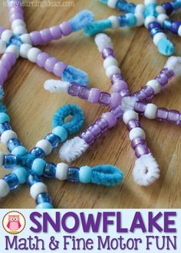  Penguin Projects  Members will make their own penguins! See picture.  Winter Coloring Sheets & Movie  Members will color winter-themed sheets and watch a movie. Allow a member to choose the movie.
Winter Wonderland! Supply List

 | Games Room | Learning Center | Pre-Teen Center | Gym | Art Room
Supplies | Coloring sheets, markers, crayons, video games, 2 buckets of supplies (cupstacks, balls, pipe cleaners, legos, etc.), table top tournament form. | Legos, movies, baking soda, hair conditioner, plastic container or tub, fun tools like beads, playdoh tools, large marshmallows, small marshmallows, food coloring pens, winter books, Christmas music | White balloons, playdoh, sharpies, computers, snow white, coloring sheets | Dodgeballs, obstacles (nets, large cupstacks, hoops, etc.), balls, buckets (or large cupstacks), basketballs | Pipe cleaners, pony beads, orange, black, and white construction paper, scissors, googly eyes, markers, Winter coloring sheets, movie

Additional supplies: white prizes, white candy

New Year, New You!
December to Remember Schedule:
Friday, December 29th
Sertoma Unit Boys & Girls Club

 | Games Room | Learning Center | Pre-teen Center | Gym | Art Room
7:30am | Table Top Games & Coloring  8:30am-Breakfast | LEGOS & A Movie  8:30am-Breakfast | CLOSED | CLOSED | CLOSED
8:55am | SWITCH TIME | SWITCH TIME | SWITCH TIME | SWITCH TIME | SWITCH TIME
9:00am | New Year Wishing Tree & Board Games | 2018  Party Slime | DIY Paper Fortune Cookies & A Movie | New Year’s Soccer GOALS! | 2017 in Review All About Me Coloring Sheets
9:55am | SWITCH TIME | SWITCH TIME | SWITCH TIME | SWITCH TIME | SWITCH TIME
10:00am | New Year’s Video Games & Board Games!  11:00am-Lunch | New Year Party Hat Treats  11:00am-Lunch | DIY Paper Fortune Cookies & A Movie  11:00am-Lunch | New Year’s Soccer GOALS!  11:00am-Lunch | 2017 in Review All About Me Coloring Sheets  11:00am-Lunch
11:30am | SWITCH TIME in cafe | SWITCH TIME in cafe | SWITCH TIME in cafe | SWITCH TIME in cafe | SWITCH TIME in cafe
12:30pm | Table Tops & Coloring | New Year Party Hat Treats | New Year’s Fort Building & Pictionary | Outside OR Stations | New Year Wishing Wands
1:25pm | SWITCH TIME | SWITCH TIME | SWITCH TIME | SWITCH TIME | SWITCH TIME
1:30pm | Table Tops & Coloring | 2018 New Year Goal Sheet & Dance Party | New Year’s Fort Building & Pictionary | Outside OR Stations | New Year Wishing Wands
2:25pm | SWITCH TIME | SWITCH TIME | SWITCH TIME | SWITCH TIME | SWITCH TIME
2:30pm | MEMBER CHOICE  Snack-2:40pm | MEMBER CHOICE  Snack-2:40pm | MEMBER CHOICE  Snack-3:00pm | MEMBER CHOICE  Snack-3:20pm | MEMBER CHOICE  Snack-3:00pm
3:55pm | SWITCH TIME | SWITCH TIME | SWITCH TIME | SWITCH TIME | SWITCH TIME
4:00pm | “New Year’s Eve” Celebration in the Gym | “New Year’s Eve” Celebration in the Gym | “New Year’s Eve” Celebration in the Gym | “New Year’s Eve” Celebration in the Gym | “New Year’s Eve” Celebration in the Gym
5:00pm | Consolidation in Games Room | Consolidation in Games Room | Consolidation in Games Room | Consolidation in Games Room | Consolidation in Games Room

New Year Celebration Schedule of Events

4:00pm | Meet in gym, go over expectations and party!
4:05pm | Recognition from the day: Awards for New Year, New You Members!  Share New Year’s Resolutions
4:15pm | Ball Drop
4:20pm | Party! (front desk available for sensory kiddos-coloring sheets)  Music, group dances, games, etc.

New Year, New You! Supply List

 | Games Room | Learning Center | Pre-Teen Center | Gym | Art Room
Supplies | Table Top Games & Coloring  Members will have free play.  New Year Wishing Tree & Board Games  Members will make their own wishing tree ornaments and place them on the wishing tree. They will write their wish on the ornament with sharpies. Members will also play board games! Allow members to choose their games.  New Year’s Video Games & Board Games!  Members will play video games (member choice) and play board games (member choice)  Table Tops & Coloring  Members will rotate table tops and have the option to color at the tables. | LEGOS & A Movie  Members will have free LEGO play and watch a movie.  2018 Party Slime  Members will make their own new year slime! 1 cup of glitter glue, 1 & 1/2 cups very warm water. Combine and mix the above ingredients in a bowl. In a second bowl combine 3/4 teaspoons of borax, 1 & 1/3 cups very warm water Mix the borax into the water and dissolve. Once the ingredients of both bowls are mixed combine both bowls. Mix the ingredients with your hands here will be water left over in the bowl. Can be thrown away. Add sequence if you’d like.  New Year Party Hat Treats  Members will make their own party hats with waffle cones, frosting, and sprinkles, etc.  2018 New Year Goal Sheet & Dance Party  Members will complete a 2018 goal sheet and have a dance party! | DIY Paper Fortune Cookies & A Movie  Members will watch a movie as they make fortune cookies. Picture instructions below.  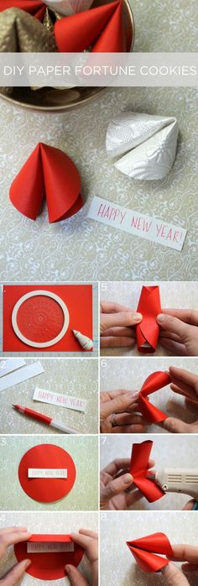  New Year’s Fort Building & Pictionary  Members will use PTC materials and build their own forts and play Pictionary! | New Year’s Soccer GOALS!  Members will attempt to score goals using a soccer ball. There will be many goals set up in the gym, some difficult, some easy. Members will rotate through the challenges and attempt to earn the most points.  Outside OR Stations  Members will go outside, weather permitting. If not, they will rotate to and from the following stations:  Shoot out, high jump, cone race, jump rope, hula hoops, tennis dribble. | 2017 in Review All About Me Coloring Sheets  Members will complete an all about me coloring sheet and share big moments from their 2017.  New Year Wishing Wands  Start by cutting out a star from the piece of cardstock. Then cut an outline from that star. Stick this star frame onto piece of sticky backed plastic (contact paper) and trim around the edges. Then you can decorate. Add a stick - we used a rolled up piece of the card - and some ribbons and you're done. Then your little fairies and New Year pixies can waft around granting wishes into the New Year.  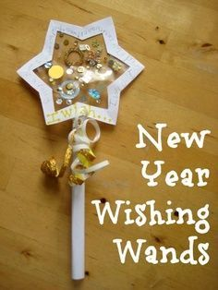

New Year, New You! Supply List

 | Games Room | Learning Center | Pre-Teen Center | Gym | Art Room
Activity Instructions | Small tree, ornament hooks, small ornaments | Legos, movie, glitter glue, water, bowls, borax, waffle cones, candy, frosting, plastic knives, 2018 goal sheet, music | Circle cutter or pre-cut circles, decorative paper, pens, white paper, scissors, hot-glue gun, fort items, expo markers, Pictionary topics or game | Soccer balls, soccer goals, buckets, etc. outside balls OR basketballs, masking tape, sharpie, cones, jump ropes, hula hoops, tennis balls, tennis racquets. | 2017 year in review sheets, markers, cardstock, scissors, contact paper (sticky), sequins, ribbon, tissue paper, dowel rods or popsicle stick, etc.

Additional supplies: Fun prizes, glow sticks, large ball, balloons, lights, music, games set up (bowling, ring toss, etc.)

