

*​“Motivating and recognizing employees is vital to employee engagement and a healthy, fun work environment. A successful organization can generally trace its success to motivated and engaged employees. Recognizing employees for specific achievements or for ongoing contributions is an excellent way to let them know they are valued.”-Human Resources at the University of Colorado-Boulder*

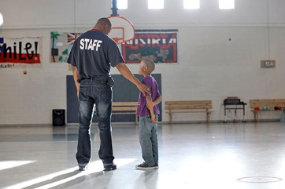

YOUTH DEVELOPMENT PROFESSIONAL OF THE MONTH DISTINCTION

**PURPOSE:** To recognize and acknowledge the Boys & Girls Club of Springfield staff members for their commitment to excellence and upholding the Boys & Girls Club mission and values.

**TARGET:** To recognize YDPs for their hard work, toYDPs for their commitment to the Club, to increase quality YDP retention, to create a positive work environment, and to offer growth potential for staff members.

**STRUCTURE:** Each month, one YDP from each of Springfield’s four Units will be chosen to represent their Unit as a candidate for the YDP of the Month Distinction. Nominations may be made by anyone (staff, member, parent, etc.). Nominators will complete the attached nomination form and turn it in to a Springfield Club Program Director for review. Program Directors will choose one representative from each Unit and will be responsible for submitting said nomination to the Director of Programs, Brandy Harris, by the first Tuesday of each month by 11:59pm. The Director of Programs will only accept nominations from Program Directors.

**RECOGNITION:** Each nominee will be featured on the Boys & Girls Clubs of Springfield’s social media pages. Each YDP on the month will receive a write up in the Challenge Newsletter, be featured on social media, receive a certificate, be able to participate in opportunities that recognize their hard work, and be eligible for the Staff of the Year award.

**YDP OF THE YEAR:** Each month’s winner will be eligible for the Staff of the Year award. This person will be recognized at the Annual Dinner, receive a plaque, and several opportunities to represent the Club as an ambassador. YDP of the Year nominees will participate in an interview process with a panel of judges from the community. This will most likely occur in the month of January. Sample interview questions include: Where do you see yourself in 5 years?, What are three words to describe your personality?, What is your biggest accomplishment at the Club?, How do you ensure that you are upholding the Club’s mission, Code, and Values?, What do you do to give back to your community?, What advice would you have for a new staff beginning at the Club?

**

[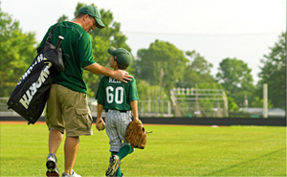](http://www.bgclubspringfield.org/programs/youth-baseball-program/)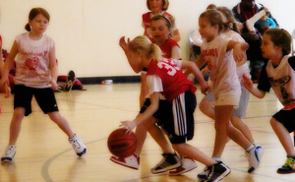[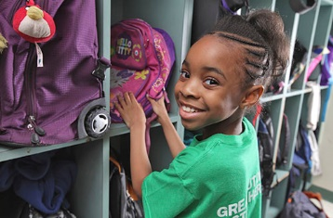](javascript:popThumbnail('https://images.printable.com/printonelogos/images/bgca_17840/GIRL_GETTING_BACKPACK_preview.JPG');)[](javascript:popThumbnail('https://images.printable.com/printonelogos/images/bgca_17840/BOY_PLAYING_POOL_preview.JPG');)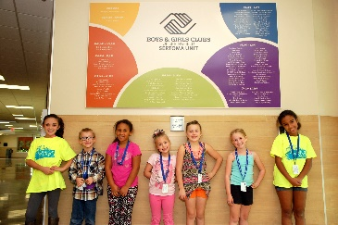



*​“Motivating and recognizing employees is vital to employee engagement and a healthy, fun work environment. A successful organization can generally trace its success to motivated and engaged employees. Recognizing employees for specific achievements or for ongoing contributions is an excellent way to let them know they are valued.”-Human Resources at the University of Colorado-Boulder*



YOUTH DEVELOPMENT PROFESSIONAL OF THE MONTH NOMINATION FORM

**Nominee Name: ___________________________________________________________**

**Nominee Email: ____________________________________________________________**

**Nominee Phone: ___________________________________________________________**

**Nominator Name: __________________________________________________________**

**Nominator Email: __________________________________________________________**

**Nominator Phone: _________________________________________________________**

**How long have you known the Nominee? _______________________________________**

**In what capacity have you known the Nominee? _________________________________**

**__________________________________________________________________________________________________________________________________________________________________**

**Why do you think this Nominee is deserving of the YDP of the Month Award?**

**________________________________________________________________________________________________________________________________________________________________________________________________________________________________________________________________________________________________________________________________________________________________________________________________________________________________________________**

**ATTACH A PICTURE OF THE NOMINEE AND FEEL FREE TO INCLUDE AN ADDITIONAL INFORMATION NECESSARY TO SUPPORT THIS NOMINATION.**

**

[](http://www.bgclubspringfield.org/programs/youth-baseball-program/)[](javascript:popThumbnail('https://images.printable.com/printonelogos/images/bgca_17840/GIRL_GETTING_BACKPACK_preview.JPG');)[](javascript:popThumbnail('https://images.printable.com/printonelogos/images/bgca_17840/BOY_PLAYING_POOL_preview.JPG');)