Namaste @ the Club
Namaste @ the Club is a program aimed to equipping members with the tools necessary to manage emotions, experience mindfulness, and understand the importance of mental stability.

Schedule – [SEASON/YEAR] Spring 2018
Date/Time – [DAYS/TIMES] Mondays 3:30pm-4:45pm
Area – [LOCATION] Gym
Staff – [STAFF NAME/AREA] Ms. Julia and Mr. Sam, Gym Coordinators
Color/Ages – [COLOR GROUP SERVED/AGES SERVED] Yellows & Oranges- Ages 5-8
Core Programming Area – [CORE AREA] Academic Success; Healthy Lifestyles; Good Character & Citizenship
Program Description – [WHAT DOES YOUR PROGRAM DO? WHAT DOES IT LOOK LIKE?] Namaste @ the Club teaches members how to positively manage emotions and stay present and calm.

[PROGRAM SESSIONS]
Session 1– Introduction & What is the Present Moment
Goal: Members will participate in get to know you and introductory activity where they will learn what the present moment means. They will also learn the expectations and become familiar with the schedule for the Club.
Activity Description:
- Explain the purpose for the program.
- Explain that each session, a member or members will be recognized as the MINDFUL MEMBER. They will earn a mindful prize (i.e. stress ball, fidget spinner, yoga mat, etc.).
- What is the Present Moment?
  - Begin by asking members what they think the “present moment” is? Ask them to use descriptive words.
  - Next, show the What is the Present moment video (https://annakaharris.com/mindfulness-for-children/) located towards the bottom of the page.
  - Ask members what they learned from the video
- Award a Mindful Member!

Objective: 20-25 members with 80% participation.
Supplies: Speakers, website What is the Present Moment Video (https://annakaharris.com/mindfulness-for-children/), prize for mindful member.

Session 2– Mindful Hearing
Goal: Members will participate an activity heightening their understanding of Mindful Hearing.
Activity Description:
- Begin this session asking members to discuss what they remember from the previous session.
- Explain the purpose of the program and remind them about the MINDFUL MEMBER award.
- Mindful Hearing
  - In this exercise, children are guided through an experience of paying attention to sounds. After some practice, children may find this exercise to be helpful in their daily lives – before doing homework, when they are having difficulty settling down at bedtime, or at other any other time when it would be useful to settle the mind.
  - Play the Mindful Hearing audio clip (https://annakaharris.com/mindfulness-for-children/) located towards the top of the page.
  - Monitor the room as members participate, guiding members if necessary.
  - Ask members what they learned and noticed.
  - Ask how Mindful Hearing can help us if we are stressed or angry, etc.
- Award a Mindful Member!

Objective: 20-25 members with 80% participation.
Supplies: Speakers, website for audio clip (https://annakaharris.com/mindfulness-for-children/), prize for mindful member.

Session 3– Stress
Goal: Members will learn new ways to manage stress.
Activity Description:
- Begin this session asking members to share what moments in their lives have cause stress.
- Explain the purpose of the program and remind them about the MINDFUL MEMBER award.
- Explain different ways to deal with stress. Ask for the group to share their strategies too.
  - Mindfulness
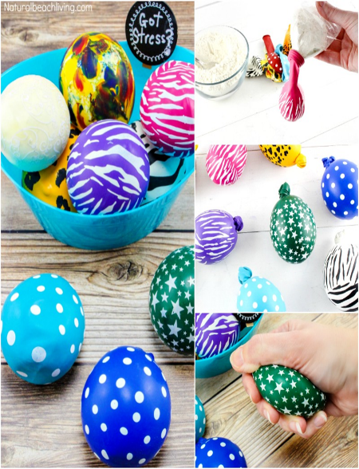
  - Meditation
  - Yoga
  - Exercise
  - Plenty of sleep
  - Ask for help
  - Relief: i.e. stress balls, calm jars, etc.
- Stress Balls
  - Put funnel into the water bottle, and pour flour through it.
  - Stretch the balloon around the opening of the water bottle.
  - Turn water bottle upside down and gently squeeze the flour into the balloon. Make sure to use some pressure because the air helps the balloon open up so the flour can all go in.
  - After the flour is all in, pinch the balloon and release it from the bottle.
  - The balloon should have a snug fit to the flour inside it. Just make sure there isn’t any extra air the balloon.
  - Tie the balloon and wipe away any excess flour from the outside.
  - All ready to squeeze away stress and have fun!
- Award a Mindful Member!

Objective: 20-25 members with 80% participation.
Supplies: Balloons, ½ cup Flour (per balloon, approx.), Empty Water Bottle (dry), Funnel

Session 4– Mindful Breathing
Goal: Members will participate an activity heightening their understanding of Mindful Breathing.
Activity Description:
- Begin this session asking members to discuss what they remember from the previous sessions.
- Explain the purpose of the program and remind them about the MINDFUL MEMBER award.
- Mindful Breathing
  - In this exercise, children are guided through a process of paying attention to the breath. There are two versions of the guided exercise below – the first is the full exercise and is intended for children who have had some practice, and the second is a slightly modified version for beginners. Choose based on your assessment of members so far!
  - Play the Mindful Breathing audio clip (https://annakaharris.com/mindfulness-for-children/) located towards the middle of the page.
  - Monitor the room as members participate, guiding members if necessary.
  - Ask members what they learned and noticed.
  - Ask how Mindful Breathing can help us if we are stressed or angry, etc. How can it calm us down?
- Award a Mindful Member!

Objective: 20-25 members with 80% participation.
Supplies: Speakers, website for audio clip (https://annakaharris.com/mindfulness-for-children/), prize for mindful member.

Session 5– Yoga Level 1
Goal: Members will participate an activity heightening their understanding of the benefits of yoga when it comes to mindfulness and stress management.
Activity Description:
- Begin this session asking members to discuss what they remember from the previous sessions.
- Explain the purpose of the program and remind them about the MINDFUL MEMBER award.
- Begin by showing members how to do the basic poses outlined on the chart below. Explain that later in the program, they will be doing some more advanced yoga. You could even have members rotate and lead a new pose for the group. Play soft music if you would like and remind members about mindful hearing.
- Award a Mindful Member!

Objective: 20-25 members with 80% participation.
Supplies: Speakers, soft music, chart below, yoga mats
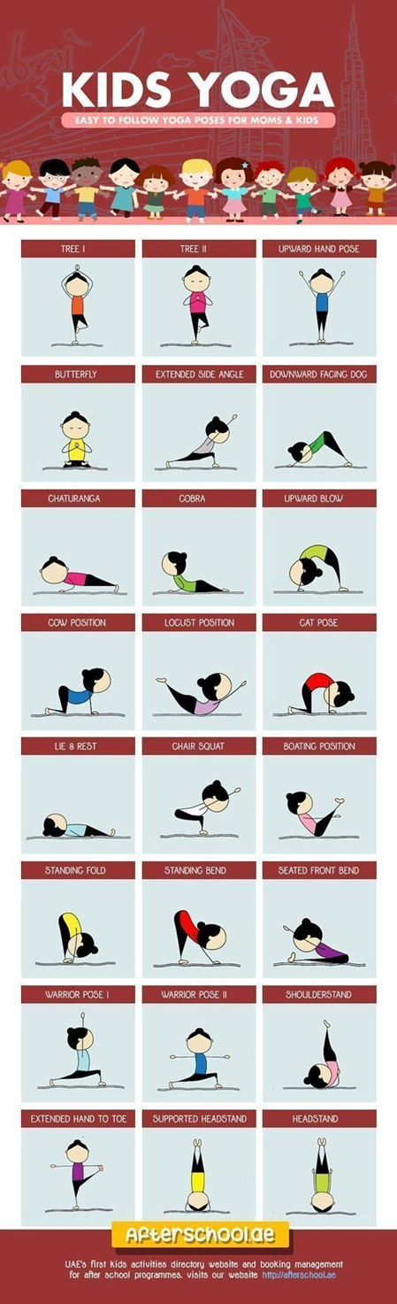
Session 6– Mindful Seeing
Goal: Members will participate an activity heightening their understanding of Mindful Seeing.
Activity Description:
- Begin this session asking members to discuss what they remember from the previous sessions.
- Explain the purpose of the program and remind them about the MINDFUL MEMBER award.
- Mindful Seeing
  - In this exercise, children pay close attention to the experience of seeing. Before sitting down to listen to the meditation, find a small rock or stone for children to use as a “focus rock”. In the first clip, during the meditation, the teacher briefly talk about the unique qualities of the present moment. For repeated use, the second version has this portion of the recording omitted so that children can choose not to listen to it every time.
  - Play the Mindful Seeing audio clip (https://annakaharris.com/mindfulness-for-children/) located towards the middle of the page.
  - Monitor the room as members participate, guiding members if necessary.
  - Ask members what they learned and noticed.
  - Ask how Mindful Seeing can help us if we are stressed or angry, etc. How can it calm us down?
- Award a Mindful Member!

Objective: 20-25 members with 80% participation.
Supplies: Speakers, website for audio clip (https://annakaharris.com/mindfulness-for-children/), prize for mindful member.

Session 7– Blind-Fold Taste Testing
Goal: Members will participate an activity heightening their senses and ability to focus.
Activity Description:
- Begin this session asking members to discuss what they remember from the previous sessions.
- Explain the purpose of the program and remind them about the MINDFUL MEMBER award.
- Blind-Fold Taste Testing
  - Begin by explaining the expectations and be sure to be aware of any food allergies.
  - This can be done in small groups or individually. Blind-fold a member or members and ask them to be mindful of how they are feeling in the present moment. Ask them to describe everything they can.
  - Members will investigate one food item at a time using all of the senses, (sight, hearing, touch, smell, taste), as if you have never experienced it before.
  - Some items you can use: dried fruit, chocolate, cracker, popcorn, jello, etc.
- Award a Mindful Member!

Objective: 20-25 members with 80% participation.
Supplies: foods, blindfolds, items to clean up if necessary, Prize for mindful member

Session 8– Yoga Level 2
Goal: Members will participate an activity heightening their understanding of the benefits of yoga when it comes to mindfulness and stress management.
Activity Description:
- Begin this session asking members to discuss what they remember from the previous sessions.
- Explain the purpose of the program and remind them about the MINDFUL MEMBER award.
- Frozen Yoga
  - Go to https://www.youtube.com/watch?v=xlg052EKMtk and show the guided yoga video!
  - Monitor the room as members participate, guiding members if necessary.
  - Ask members what they learned and noticed.
  - Ask how Yogacan help us if we are stressed or angry, etc. How can it calm us down?
- Award a Mindful Member!

Objective: 20-25 members with 80% participation.
Supplies: Speakers, website for video (https://www.youtube.com/watch?v=xlg052EKMtk), prize for mindful member.

Session 9– Mindfulness Jars
Goal: Members will participate an activity heightening their understanding of the benefits of yoga when it comes to mindfulness and stress management.
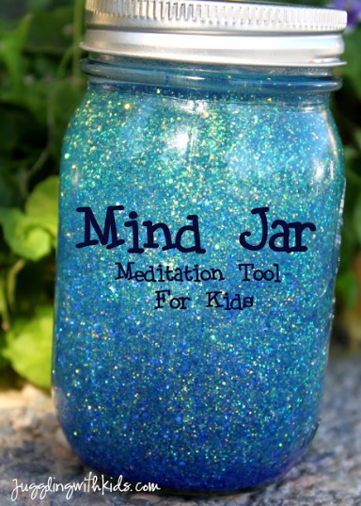
Activity Description:
- Begin this session asking members to discuss what they remember from the previous sessions.
- Explain the purpose of the program and remind them about the MINDFUL MEMBER award.
- Ask members to share why they think a mindfulness jar can help them with stress or being in the present moment.
- Mindfulness Jars
  - Mix about 1 tablespoon of glitter glue with 1 cup of warm water…depending on the size of your jar. My jar was a bit bigger so I used 2 tablespoons of glitter glue and 2 cups of warm water.
- After the jars are complete, ask members to sit quietly and focus on the glitter swirling.
- Have members share their thoughts!
- Award a Mindful Member!

Objective: 20-25 members with 80% participation.
Supplies: Mason Jar, Glitter Glue, Food Coloring, Warm Water (hot water is better), Prize for mindful member

Session 10– Friendly Wishes
Goal: Members will participate an activity heightening their compassion, awareness, and concentration.
Activity Description:
- Begin this session asking members to discuss what they remember from the previous sessions.
- Explain the purpose of the program and remind them about the MINDFUL MEMBER award.
- Mindful Seeing
  - These three exercises are guided visualizations called “Friendly Wishes,” and they focus specifically on developing compassion, in addition to concentration and awareness.
  - Play the clips (https://annakaharris.com/mindfulness-for-children/) located towards the middle of the page.
  - Monitor the room as members participate, guiding members if necessary.
  - Ask members what they learned and noticed.
  - Ask how this kind of thinking can help us become better people and how it can help if we are stressed or angry, etc. How can it calm us down?
- Award a Mindful Member!

Objective: 20-25 members with 80% participation.
Supplies: Speakers, website for audio clip (https://annakaharris.com/mindfulness-for-children/), prize for mindful member.

Session 11– Fidget Spinners
Goal: Members will participate an activity heightening their ability to remain calm and focus.
Activity Description:
- Begin this session asking members to discuss what they remember from the previous sessions.
- Explain the purpose of the program and remind them about the MINDFUL MEMBER award.
- Explain how fidget spinners are fun, but also have a purpose. Ask members to share what they think some of those purposes are.
- DIY Fidget Spinners
  - Use the included PDF Instructions to have members create their own fidget spinners!
- Award a Mindful Member!

Objective: 20-25 members with 80% participation.
Supplies: cardboard (any card will do, if it is a little thin, use two layers and glue together), toothpicks, 2 -3 penny coins, or buttons per spinner, strong PVA glue or hot glue gun, a pin, scissors, prize for mindful member

Session 12– Mindful Groups
Goal: Members will participate an activity heightening their ability to work as a group and stay mindful.
Activity Description:
- Begin this session asking members to discuss what they remember from the previous sessions.
- Explain the purpose of the program and remind them about the MINDFUL MEMBER award.
- Divide members into small groups (pairs or 3-4). Hand out the deck of mindful cards to each group. Members will rotate reading or modeling the card as the others follow.
- Award a Mindful Member!

Objective: 20-25 members with 80% participation.
Supplies: Mindfulness Cards, prize for mindful members

Session 13– Mindful Games
Goal: Members will participate activities increasing their ability to stay focused, have fun, and be mindful.
Activity Description:
- Begin this session asking members to discuss what they remember from the previous sessions.
- Explain the purpose of the program and remind them about the MINDFUL MEMBER award.
- Bubble Blow
  - This is a lovely way to slow things down. Encourage members to breathe in deep and out slowly and watch as they become engrossed in the slow, gentle movement of the bubbles they blow. This is a sensory experience for body and mind and takes them away from the analytical mode of learning.
- Pin Wheels
  - Give each member a pinwheel (you can also pair up) This is a breathing practice that also captivates their visual senses and slows things right down. Easier and more colorful than blowing bubbles, it galvanizes their focus, develops concentration and encourages stillness.
- Balloon Bounce
  - Play with just one balloon per member and ask them to pop them gently into the air with your hands, trying to keep them afloat. This is a good way of slowing down more active kids who still might need a little more movement to keep them engaged in mindful games. Their whole body and mind is engaged on a single focus.
- Award a Mindful Member!

Objective: 20-25 members with 80% participation.
Supplies: Bubbles, Pinwheels, Balloons, prize for mindful member

